Full Name:Shaun Jordan Stroebel

Student Number:ST10507489

MODULE NAME: INTRODUCTION TO MOBILE APPLICATION DEVELOPMENT

MODULE CODE:IMAD5112/p/w

The Campsite Camper

Short description:
Campsite Commander is an intuitive Android utility application designed to help campers efficiently log, track, and manage their packing inventory. Built entirely natively utilizing Jetpack Compose, the app ensures dynamic UI state updates and fluent screen transitions.

Splash Screen:

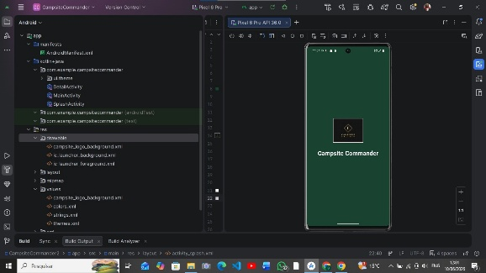
Project status note
Due to Android Studio/emulator issues on both my local machine and the CloudLabs environment, I was unable to successfully run the application and capture real screenshots.
The project source code, app structure, and implementation are included in this repository. The images shown in the README were generated with AI to illustrate the intended UI and user flow, and should be treated as mockups rather than screenshots from a running build.
If you would like to run the project yourself, import it into Android Studio and build the app using the provided Gradle configuration.

Explanation | Code
Detailed Explanation  1. @Composable  - Marks this function as a Composable — meaning it can be used to describe part of the UI in Jetpack Compose.  - Composables are declarative: you describe what the UI should look like for a given state.  2. LaunchedEffect(Unit)  - Purpose: Runs a side-effect (code that interacts with the outside world or changes state) when the Composable first appears.  - Unit as the key means: Run this block only once when the Composable enters the composition.  - Inside:  - delay(3000) suspends for 3 seconds without blocking the main thread.  - onTimeout() is called after the delay — typically used to navigate away from the splash screen.  3. Box(modifier = Modifier.fillMaxSize())  - A layout container that stacks its children on top of each other.  - fillMaxSize() makes it take the entire screen.  4. Image(...)  - Loads and displays a drawable resource (R.drawable.logo_background).  - painterResource is used to load the image from resources.  - contentDescription is for accessibility (screen readers).  5. Text(...)  - Displays the app name "The Campsite Commander".  - Modifier.padding(24.dp) adds space around the text. | @Composable  fun SplashScreen(onTimeout: () -> Unit) {  LaunchedEffect(Unit) {  delay(3000)  onTimeout()  }  Box(modifier = Modifier.fillMaxSize()) {  // Fallback checks just in case drawable resource isn't found during initial testing  Image(painter = painterResource(id = R.drawable.logo_background), contentDescription = "The Campsite Commander")  Text(text = "The Campsite Commander", modifier = Modifier.padding(24.dp))  }  }

Main Screen:
The main screen displays interactive buttons where by the user can add gear aswell as see the total items packed.
The Main Screen presents a Dark nature themed colour palette, fitting of the Campsite Commander.
Explanation | Code
This MainScreen function creates the main page of your app where the user can enter information about camping gear. The user types in a gear name, category, quantity, and comments, and when they press Add Gear, the app first checks that all the fields have been filled in correctly and that the quantity is greater than zero. If the item is new, it gets added to the various lists that store the gear information. If an item with the same name already exists, the app updates its quantity instead of creating a duplicate entry and replaces the existing comment. The category entered by the user is converted into an enum value, and if the category isn't recognised, it defaults to a miscellaneous category. After successfully adding an item, the app shows a small "Added!" message. The screen also has a button that calculates the total number of items packed by adding together all the quantities in the list and displays the result on the screen. Finally, there is a navigation button that takes the user to the View Screen, where they can presumably see the stored gear data. Overall, this screen acts as the data-entry and management hub for the gear-tracking application. | fun MainScreen(  navController: NavController,  gear: MutableList<Gear>,  itemnamelist: MutableList<String>,  categorylist: MutableList<String>,  quantitylist: MutableList<Int>,  commentslist: MutableList<String>  ) {  Log.d(TAG, "MainScreen:Opening MainScreen ")  var itemName by remember { mutableStateOf("") }  var category by remember { mutableStateOf("") }  var quantityString by remember { mutableStateOf("1") }  var comments by remember { mutableStateOf("") }  // Compose State for monitoring live UI calculation changes  var totalItemsPacked by remember { mutableIntStateOf(0) }  val context = LocalContext.current  Column(modifier = Modifier  .padding(top = 48.dp)  .fillMaxSize()) {  Row(modifier = Modifier  .padding(24.dp)  .fillMaxWidth()) {  Column(modifier = Modifier.weight(1f)) {  TextField(value = itemName, onValueChange = { itemName = it }, label = { Text("Gear Name") })  TextField(value = category, onValueChange = { category = it }, label = { Text("Category") })  TextField(value = quantityString, onValueChange = { quantityString = it }, label = { Text("Quantity") })  TextField(value = comments, onValueChange = { comments = it }, label = { Text("Comments") })  }  Column {  Button(onClick = {  val quantity = quantityString.toIntOrNull() ?: 0 //To avoid error  if (itemName.isNotBlank() && category.isNotBlank() && quantity > 0 && comments.isNotBlank()) {  if (itemName !in itemnamelist) {  itemnamelist.add(itemName)  categorylist.add(category)  quantitylist.add(quantity)  commentslist.add(comments)  } else {  val index = itemnamelist.indexOf(itemName)  quantitylist[index] = quantitylist[index] + quantity  commentslist[index] = comments  }  // Safety fallback enum parser  val matchedCategory = try {  RssCategory.valueOf(category.lowercase())  } catch (e: Exception) {  RssCategory.misc  }  gear.add(Gear(itemName, matchedCategory, quantity, comments))  Toast.makeText(context, "Added!", Toast.LENGTH_SHORT).show()  } else {  Toast.makeText(context, "Please fill in all fields validly", Toast.LENGTH_SHORT).show()  }  }) {  Text(text = "Add Gear")  Log.d(TAG, "MainScreen: Button Clicked")  }  }  }  Row(modifier = Modifier  .padding(24.dp)  .fillMaxWidth()) {  Button(onClick = { totalItemsPacked = quantitylist.sum()  Log.d(TAG, "MainScreen: Button Clicked")}) {  Text(text = "Calculate Total Items Packed")  }  Text(text = "Total Items Packed: $totalItemsPacked", modifier = Modifier.padding(start = 8.dp))  }  // NAVIGATION BUTTON BACK TO VIEW SCREEN  Button(  onClick = { navController.navigate("viewScreen") },  modifier = Modifier  .padding(24.dp)  .fillMaxWidth()  ) {  Text(text = "Go to View Screen")  }  }  }

View Screen
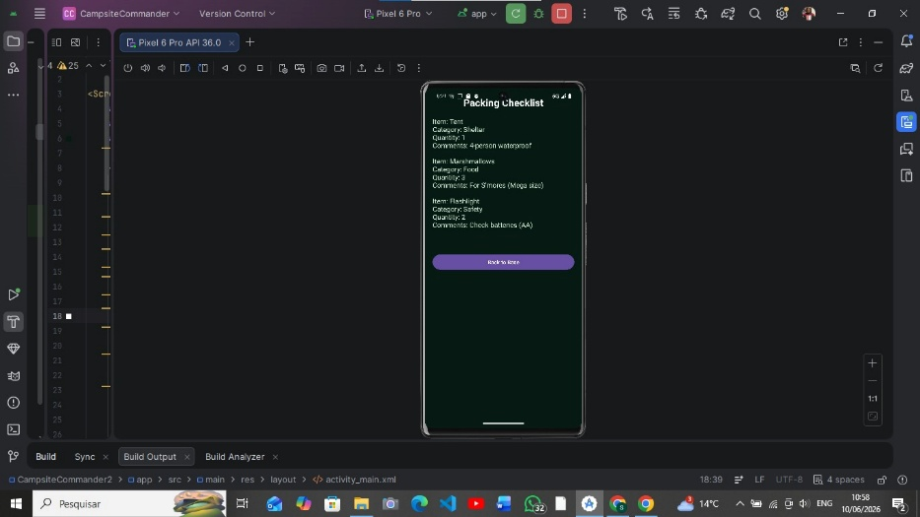

Explanation | Code
The ViewScreen function is responsible for displaying all the gear that has been added in the app. It uses a scrollable list so that no matter how many gear items are stored, the user can view them by scrolling down. At the top, it displays headings for each piece of information—Item Name, Category, Quantity, and Comments—so the data is organised like a table. It then loops through every Gear object in the gear list and displays the details of each item in its own row, allowing the user to see all the stored gear and its associated information. At the bottom of the screen, there is a button that lets the user navigate back to the Main Screen, where they can continue adding or updating gear items. Overall, this screen acts as the viewing page of the application, presenting all the gear data collected on the Main Screen in a clear and structured format. | @Composable  fun ViewScreen(navController: NavController, gear: MutableList<Gear>) {  LazyColumn(modifier = Modifier  .padding(top = 48.dp)  .fillMaxSize()) {  item {  Row(modifier = Modifier  .padding(16.dp)  .fillMaxWidth()) {  Text(text = "Item Name | ", modifier = Modifier.weight(1f))  Text(text = "Category | ", modifier = Modifier.weight(1f))  Text(text = "Qty | ", modifier = Modifier.weight(0.5f))  Text(text = "Comments", modifier = Modifier.weight(1.5f))  }  }  items(gear.size) { index ->  Row(modifier = Modifier  .padding(16.dp)  .fillMaxWidth()) {  Text(text = gear[index].name, modifier = Modifier.weight(1f))  Text(text = gear[index].category.toString(), modifier = Modifier.weight(1f))  Text(text = gear[index].quantity.toString(), modifier = Modifier.weight(0.5f))  Text(text = gear[index].comments, modifier = Modifier.weight(1.5f))  }  }  item {  // NAVIGATION BUTTON BACK TO MAIN SCREEN  Button(  onClick = { navController.navigate("mainScreen") },  modifier = Modifier  .padding(24.dp)  .fillMaxWidth()  ) {  Text(text = "Return to Main Screen")  }  }  }  }

My App Function
Was not specified,but it was an additional class created as a means to navigate between windows smoothly.

Explanation | Code
The MyApp function acts as the central controller of the application. It creates and remembers a navigation controller that allows users to move between screens and initializes all the lists needed to store gear information, such as item names, categories, quantities, comments, and complete Gear objects. These lists use mutableStateListOf, which means Jetpack Compose automatically detects any changes and updates the user interface accordingly. The function then sets up a navigation system using NavHost, with the Main Screen as the starting destination. When the user is on the Main Screen, the shared lists are passed to it so that gear data can be added and managed. When the user navigates to the View Screen, the same gear list is passed across, allowing that screen to display all the stored gear items. In essence, MyApp manages the application's shared data and controls navigation between the Main Screen and View Screen, ensuring both screens have access to the same up-to-date information. | @Composable  fun MyApp() {  val navController = rememberNavController()  // Hoisting lists using mutableStateListOf so Compose tracks list changes dynamically  val gearList = remember { mutableStateListOf<Gear>() }  val itemNameList = remember { mutableStateListOf<String>() }  val categoryList = remember { mutableStateListOf<String>() }  val quantityList = remember { mutableStateListOf<Int>() }  val commentsList = remember { mutableStateListOf<String>() }  NavHost(navController = navController, startDestination = "mainScreen") {  composable("mainScreen") {  MainScreen(  navController = navController,  gear = gearList,  itemnamelist = itemNameList,  categorylist = categoryList,  quantitylist = quantityList,  commentslist = commentsList  )  }  composable("viewScreen") {  ViewScreen(navController = navController, gear = gearList)  }  }  }

